**Error Analysis**

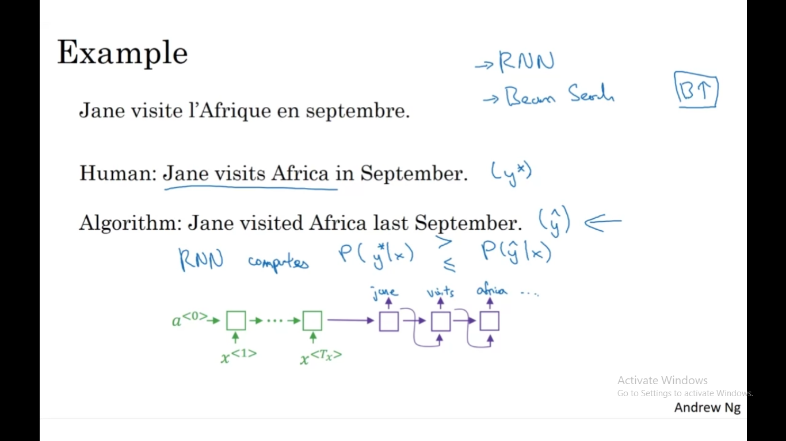

**4.Suppose you are building a speech recognition system, which uses an RNN model to map from audio clip xx to a text transcript yy.**

**Your algorithm uses beam search to try to find the value of yy that maximizes P(y∣x).**

**On a dev set example, given an input audio clip, your algorithm outputs the transcript y^= “I’m building an A Eye system in Silly con Valley.”, whereas a human gives a much superior transcript y∗ = “I’m building an AI system in Silicon Valley.”**

**According to your model,**

**P(y^∣x)=1.09∗10−7 P(y∗∣x)=7.21∗10−8**

**Would you expect increasing the beam width B to help correct this example?**

a)No, because P(y∗∣x)≤P(y^∣x) indicates the error should be attributed to the RNN rather than to the search algorithm.

b)No, because P(y∗∣x)≤P(y^∣x) indicates the error should be attributed to the search algorithm rather than to the RNN.

c)Yes, because P(y∗∣x)≤P(y^∣x) indicates the error should be attributed to the RNN rather than to the search algorithm.

d)Yes, because P(y∗∣x)≤P(y^∣x) indicates the error should be attributed to the search algorithm rather than to the RNN.

Answer: a

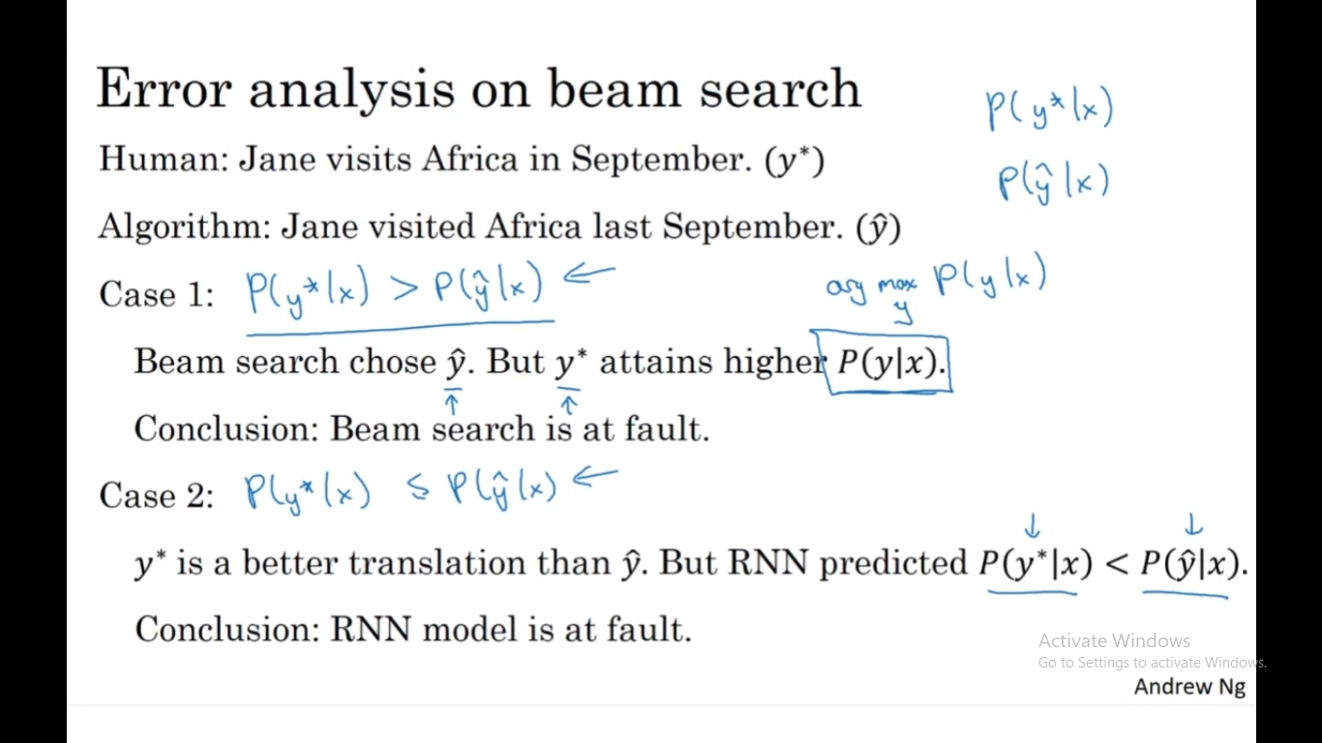

**5.Continuing the example from Q4, suppose you work on your algorithm for a few more weeks, and now find that for the vast majority of examples on which your algorithm makes a mistake, P(y∗∣x)>P(y^∣x). This suggest you should focus your attention on improving the search algorithm.**

a)True

b)False

Answer: a

